Parth Babbar

9999940289  kishibabbar@gmail.com

Federal deposit insurance corporation

**Introduction:**

The Federal Deposit Insurance Corporation (FDIC) is an independent federal organisation created to protect the stability and public trust in the United States' financial system. It accomplishes this by insuring deposits, inspecting and overseeing financial institutions, and handling receiverships. The FDIC protects depositors and strengthens trust in the financial system by insuring banks and thrift institutions, thereby contributing significantly to the nation's financial stability.

**History & Background:**

1. **Establishment Date:** June 16,1993  
   
2. **Legislation:** The Banking Act of 1933, popularly known as the Glass-Steagall Act.
3. **History:** Founded during the Great Depression in reaction to approximately 9,000 bank failures between 1929 and 1933.  
   
4. **Purpose:** To ensure stability and public trust in the nation's financial system.
5. **Function:** Insuring deposits, Inspecting and monitoring financial institutions & Manage receiverships.
6. **Role:** Protects depositors and builds trust in the financial system.
7. **Banks under FDIC:** As of 2023, 4470 commercial banks are under FDIC.  
     
   A graph of a number of blue bars

   Description automatically generated with medium confidence

**Function:**

The main function of FDIC are:

1. **Deposit Insurance:** The FDIC guarantees deposits at banks and thrift institutions, providing basic financial protection with coverage of up to $250,000 per depositor, per insured bank, and across numerous account types. The FDIC, which is funded by premiums from insured institutions, not only provides depositors with safety and peace of mind, but also plays an important role in boosting trust in the banking system, therefore protecting the nation's financial health.
2. **Supervision & Regulations:** The FDIC supervises and examines financial institutions to guarantee their operational safety and soundness. It enforces consumer protection laws and uses risk management strategies to ensure regulatory compliance. By inspecting financial institutions for safety, soundness, and consumer protection, the FDIC builds trust in the banking system's integrity while protecting depositors' and consumers' interests.
3. **Management:** The FDIC serves as a receiver, managing the resolution process for bankrupt banks. It manages and sells bankrupt banks' assets while also ensuring that insured deposits are paid out in a timely manner. The FDIC seeks to minimise financial system disruptions by effectively administering the receivership and liquidation of failed banks, while still fulfilling its duty to safeguard depositors' interests.

**Goals:**

1. **Protection of Depositors:** Ensure that depositors do not lose their insured fund.
2. **Promoting the Stability:** Maintain faith in the financial system.
3. **Management:** Handle failing institutions efficiently while minimising expenses for the Deposit Insurance Fund.

**Key Programs:**

1. **Deposit Insurance Fund(DIF):** The FDIC maintains a fund to cover insured deposits in the event of a bank collapse. This fund is largely supported from premiums received from covered institutions and investment revenue. By depending on premiums and investment returns, the FDIC maintains the availability of resources to perform its vital function in preserving depositors' cash and sustaining trust in the banking system.
2. **Consumer Protection:** The FDIC enforces legislation such as the Truth in Lending Act and the Fair Credit Billing Act, while also offering essential consumer services and instructional materials.

**Divisions & Offices:**

The following are the divisions & offices present in FDIC:

1. **Risk Management Supervision**
2. **Depositor and Consumer Protection**
3. **Resolutions and Receiverships**
4. **Office of the Ombudsman**
5. **Office of Inspector General**

**Acts to Reform:**

1. **Dodd-Frank Act(2010):** It enhanced the FDIC's power over systemically significant financial institutions, hence improving financial stability. It also made the $250,000 insurance coverage limit permanent, which increased trust in the financial system's stability. Also it affected the employment & unemployment rate.  
   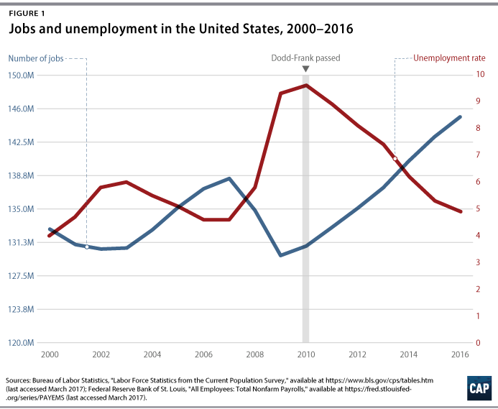
2. **FDIC Improvement Act(1991):** It increased the FDIC's ability to manage bank failures, protecting the financial system from possible catastrophes. It also implemented a risk-based assessment system and increased capital norms, promoting conservative management practices in financial institutions.

**Conclusion:**

The FDIC is a vital component of the United States' financial system, providing services that safeguard depositors, promote stability, and preserve trust in the banking system. Its function in protecting deposits, overseeing banks, and handling bankrupt organisations makes the financial ecosystem safer and more secure for everyone.